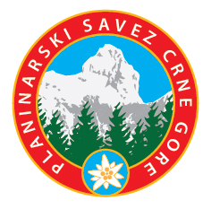
PLANINARSKI SAVEZ CRNE GORE
MOUNTAINEERING ASSOCIATION OF MONTENEGRO

Mountaineering Association of Montenegro (MAM), in accordance with the decision of the MB of MAM No. 105-1 of 14.05.2025., and on the occasion of celebrating the 75th anniversary of the Association, announces the International Photo Contest “Mountains of Montenegro II”

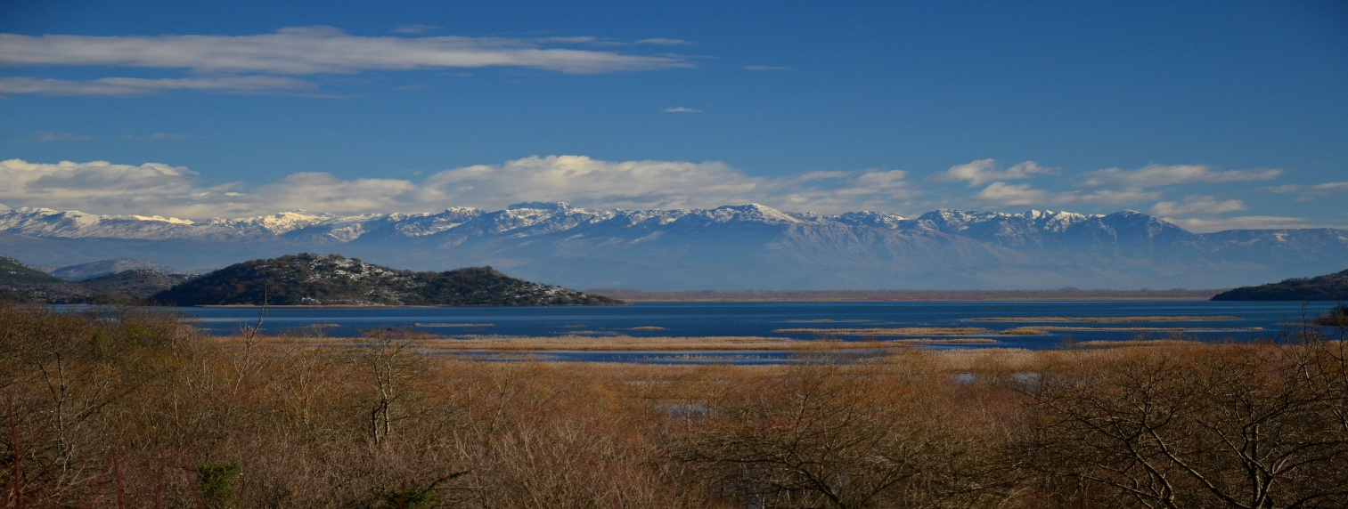

Mountaineering Association of Montenegro proudly celebrates its 75th anniversary
and on this occasion announces the
INTERNATIONAL PHOTO CONTEST
on the topic
“MOUNTAINS OF MONTENEGRO II”
Mision
Through the international photo contest “Mountains of Montenegro II”, we want to reward the best works that celebrate the exceptional beauty of the Montenegrian mountains and contribute to marking this significant anniversary of the 75th anniversary of the Mountaineering Association of Montenegro (MAM).
We invite all members, nature and photography enthusiasts, to respond to this competition and, through their lenses, show:
• the enchanting landscapes of Montenegro, where mountains emerge from the sea, rivers, canyons...
• the hidden and untouched beauty of the Montenegrian mountain expanses
• the spirit of adventure and an exploratory view of the breathtaking nature of Montenegro
It is time to discover the magic of the Montenegrian mountains - together!

1. Rules for participation in the competition

All interested domestic and foreign authors have the right to participate.
Each author can send a maximum of three of their own photos.
Participation is free of charge - no registration fee.
By sending photos, authors agree that Mountaineering Association of Montenegro (Planinarski savez Crne Gore - PSCG) can use their works for promotional and educational purposes, without financial or any compensation, with the obligatory mention of the author's name. Selected works may be displayed at exhibitions, on the MAM/PSCG website, in publications and multimedia materials.
By sending works, authors guarantee that the submitted works are original. In the event that the contrary is determined, MAM/PSCG reserves the right to cancel the awarded prize and inform the public.
By submitting works, participants accept all rules of the competition. MAM/PSCG reserves the right of final interpretation of the rules of this prize competition.

2. Technical requirements

Photographs can be in color or black and white.
Format: JPEG, resolution 300 dpi, dimensions 30x20 cm.
Allowed software processing:
• cropping;
• adjustment of contrast, exposure and lighting;
• moderate sharpening;
• moderate color saturation.

3. Rules - how to send photos

The file name should contain:
author's name and surname_photo location_photo name_serial number.jpeg
(e.g. Petar Petrović_Sedlo-Durmitor_Montenegrian mountain_1.jpeg)

Photos must contain data in the EXIF ​​record (to check the data: right-click on the photo, select the File properties option, then Details, if there is data in this column, then everything is fine).
In the e-mail subject, write: Author's name and surname - Application for the "Montenegrin Mountains II" competition

In the body of the e-mail:
• Author's name and surname
• Residential address
• Contact information (e-mail, phone, Viber, WhatsApp...)

Send photos to: info@pscg.me
It is possible to send works in multiple e-mails or as a ZIP file.
For files larger than 10 MB, use the service: www.wetransfer.com
Note: Applications that do not comply with the photo contest will not be considered.

4. Deadlines

Deadline for submitting photos: June 15, 2025, by 1:00 p.m.
Confirmation of receipt will be sent no later than June 15, 2025, by 1 p.m.
Jury: June 16–17, 2025
Announcement of results: June 18, 2025
Photo exhibition: June 27–29, 2025, Mountain Festival Mojkovac 2025, Cultural center Mojkovac.
5. Jury

The jury decides solely on the basis of the artistic and technical qualities of the works.
Jury members cannot be participants in the competition.
Jury:
• Lazar Pejović, MA - art photographer, professor of photography at the Faculty of Fine Arts in Cetinje;
• Dejan Kalezić - photographer and educator in the field of photography;
• Danilo Ivanović - photographer and member of the “Photo CG” photo club since 2010.

The jury's decision is final. The jury reserves the right not to award all prizes if the photos do not meet the expected criteria.

6. Awards

1st place award: 300 EUR
2nd place award: 200 EUR
3rd place award: 100 EUR

7. Publication of results

The results will be published on the website: www.pscg.me on June 18, 2025.
The authors of the selected and awarded works will be notified by e-mail.

8. Exhibition and award ceremony

The jury will, depending on the artistic quality of the received works, select up to 20 works, which will be exhibited during the Mountain Festival at the Cultural Center in city Mojkovac, from June 27 to 29, 2025.
The award ceremony for the three best photos will be held on June 28, 2025 as part of Mountain Festival “Mojkovac 2025”.

9. Contact
Mountaineering Association of Montenegro
e-mail: info@pscg.me
Tel: +382 20 622 220
+38263201686
Website: http://www.pscg.me

